CIS 182 – SQL Fundamentals – Winter 2024

W10 Exercises: Designing a Database

(For the due date, please refer to this lab’s posting on Canvas)

Exercises 10-1: Designing a database.

1. Create a database diagram that shows the relationships between the six tables in the MurachCollege database. (The Tuition table is not related to the other five tables.)

Please paste a screenshot of your database diagram in the boxes below.

|  |
| --- |
|  |

1. Design a database diagram for a database that stores information about the downloads that users make from a book website.

* Each user must have an email address, first name, and last name.
* Each user can have one or more downloads.
* Each download must have a filename and download date/time.
* Each book can be related to one or more downloads.
* Each book must have a name.

Please paste a screenshot of your database diagram in the boxes below.

|  |
| --- |
|  |

Exercises 10-2: Creating a database and its tables with SQL Server Management Studio

1. Write a script that implements the following design in a database named MyBookDB:

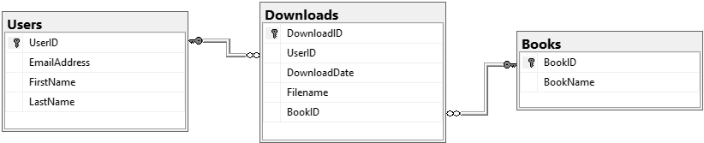

In the Downloads table, the UserID and BookID columns are the foreign keys.

Include a statement to drop the database if it already exists.

Include statements to create and select the database.

Define the BookName column so its value is unique.

Include indexes for the two foreign keys.

Please copy your SQL script as text and paste it in the box below

|  |
| --- |
| *SQL script text* |

1. Write a script that adds rows to the database that you created in exercise 1.

Add two rows to the Users and Books tables.

Add three rows to the Downloads table:

* one row for user 1 and Book 1;
* one for user 2 and Book 1; and
* one for user 2 and book 2.

Use the GETDATE function to insert the current date and time into the DownloadDate column, and include data for each of the other columns.

Please copy your SQL script as text and paste it in the box below

|  |
| --- |
| *SQL script text* |

Write a SELECT statement that joins the three tables and retrieves the data from these tables like this:

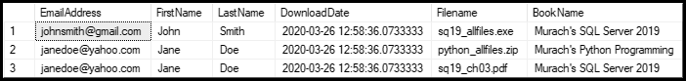

Sort the results by the email address in descending order and the book name in ascending order.

Please copy your SQL statement as text and paste it in the box below

|  |
| --- |
| *SQL text* |

Please paste a screenshot of the result of your query in the box below.

|  |
| --- |
| *Result screenshot* |

1. Write an ALTER TABLE statement that adds two new columns to the Books table created in exercise 1.

Add one column for book price that provides for three digits to the left of the decimal point and two to the right. This column should have a default value of 59.50.

Add one column for the date and time that the book was added to the database.

Please copy your SQL statement as text and paste it in the box below

|  |
| --- |
| *SQL text* |

Write a SELECT * statement on the Books table to show the new column.

Please take a screenshot of the result of your SELECT * statement in the box below.

|  |
| --- |
| *Result screenshot* |

1. Write an ALTER TABLE statement that modifies the Users table created in exercise 1 so the EmailAddress column can store a maximum of 25 characters.

Please copy your ALTER TABLE statement as text and paste it in the box below, followed by a screenshot of its execution result.

|  |
| --- |
| *SQL text* |
| *Result screenshot* |

Code another UPDATE statement that attempts to insert an email address that’s longer than 25 characters. It should fail due to the length of the column.

Please copy your UPDATE statement as text and paste it in the box below, followed by a screenshot of its execution result.

|  |
| --- |
| *SQL text* |
| *Result screenshot* |

1. Write an ALTER TABLE statement that modifies the Users table created in exercise 1 so the EmailAddress column must be unique.

Please copy your ALTER TABLE statement as text and paste it in the box below, followed by a screenshot of its execution result.

|  |
| --- |
| *SQL text* |
| *Result screenshot* |

Code an UPDATE statement that attempts to insert a nonunique value into this column. It should fail due to the unique constraint.

Please copy your UPDATE statement as text and paste it in the box below, followed by a screenshot of its execution result.

|  |
| --- |
| *SQL text* |
| *Result screenshot* |